**WHAT’S THE CRIME?**

**PROJECT AIM :** To build the website were user can search using the crime keyword and result will be the IPC code and the description about it**.**

**Site Features:**

1.Search a Criminal Keyword which triggers the Display of corresponding IPC Number and Description.

2.Gives information about the Code.

3.The Entire 511 Codes to be pre-entered in the Database.

4.Useful for People to get Details about the Code, using the Keyword they know about the Incident.

5.Final result will provide user the information about the keyword searched which with the IPC code and the description.

**THE RESULT WILL BE LIKE :**

Main page of the What’s the crime?

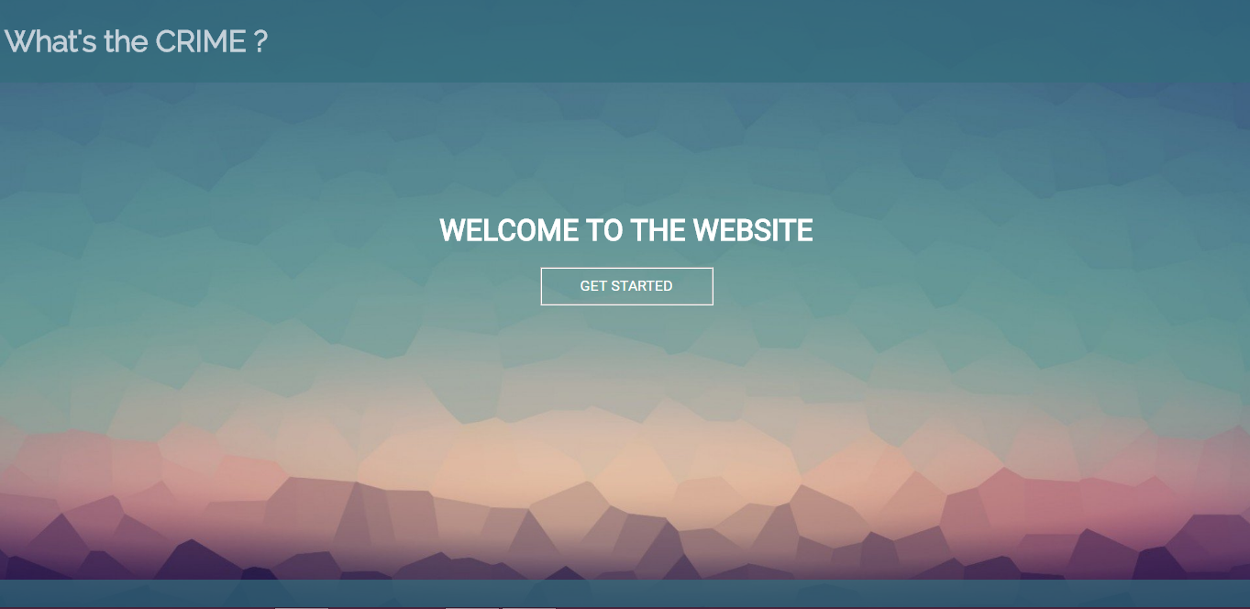

2. Search For the Crime .

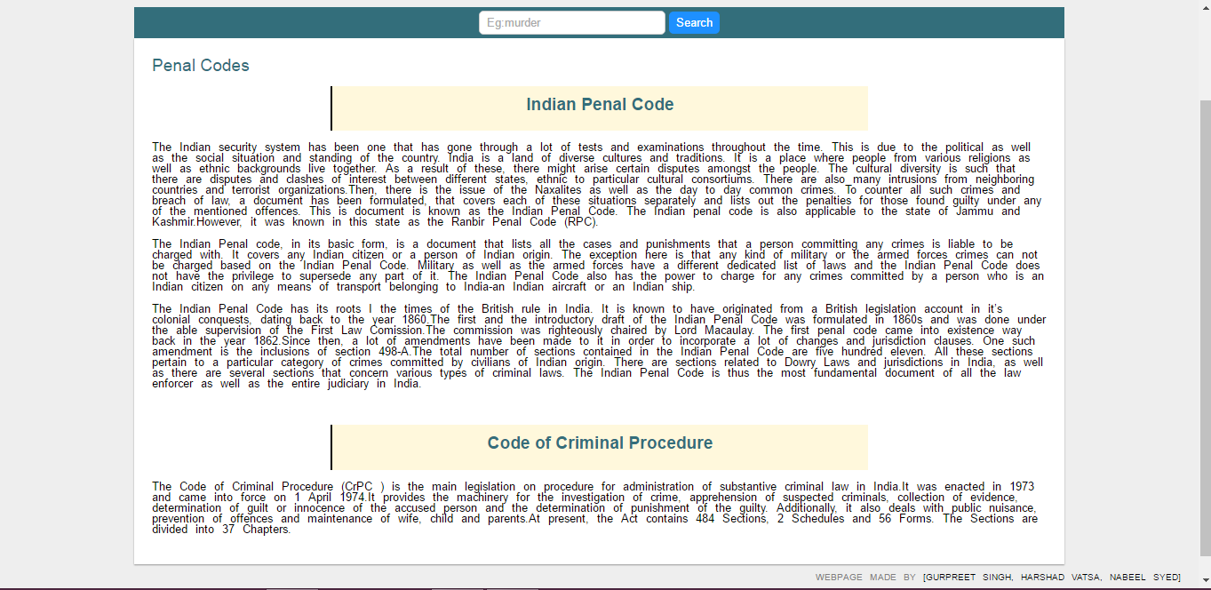

Conclusion : This site is the search engine for searching the IPC (Penal codes) using the crime for the particular crime.

MADE BY :

1. Gurpreet Singh
2. Harshad Vatsa
3. Nabeel Syed